​

*Information Technology Institute*

*Power BI Developer Track*

**Examination System**

Supervisor:

Eng. **Nadia saleh**

**Presented by:**

Abdullah Amr

Abdullah Ayman   
Ahmed Saad  
Ebrahim Rabea  
Mina Ashraf

## 

## **ABSTRACT**

This Examination System documentation provides a comprehensive guide and reference for understanding and utilizing the system.

It aims to assist administrators, academic advisors, and other stakeholders involved in the evaluation and analysis of student and instructors performance. The document covers various aspects of the examination system, including its purpose, functionality, and usage. The Examination System Documentation includes sections the explain every part of the software,Furthermore, the documentation provides insights into the evaluation process, guiding professors on how to assess student answers, assign grades, and provide feedback.

It also explores the analysis capabilities of the system, allowing stakeholders to track and analyze student performance trends, identify areas of improvement, and generate comprehensive reports.

So that any stakeholder can use it to analyze its student, instructors, departments, courses and exam data and use the drived insights from it in improving the process of his educational institution.

## **INTRODUCTION**

Welcome to the Examination System of ITI ..

Due our journey as being itian’s students in power BI Track,

we have been inspired actually to develop this examination system in   
a helpful manner,That covers different aspects of this huge educational institution so that any supervisor or manger can use it to analysis

the data of the students instructors, departments, courses and exam performance and KPIs and job offers and progress through different dashboards for each of them which will help to give a useful insights to be used.

Once exams are administered, the evaluation phase becomes crucial. Professors will find detailed instructions on how to assess student answers, assign grades, and provide valuable feedback.

As after taking the data of the students and their grades of the courses this gonna help to know their progress in the study process and will help in the end to know the performance of them and try to improve it so they can achieve the kpis in an excellent way and get a good job

So we in our system explore methods for tracking and analyzing performance trends, identifying areas of improvement, and generating comprehensive reports. These insights empower educators to make data-driven decisions and implement targeted interventions to enhance learning outcomes.

Lets start our dive into the software ..

## **Software Development life cycle**

In this section we are clarification the life cycle we have been through to develop the system:  
**The life cycle:**

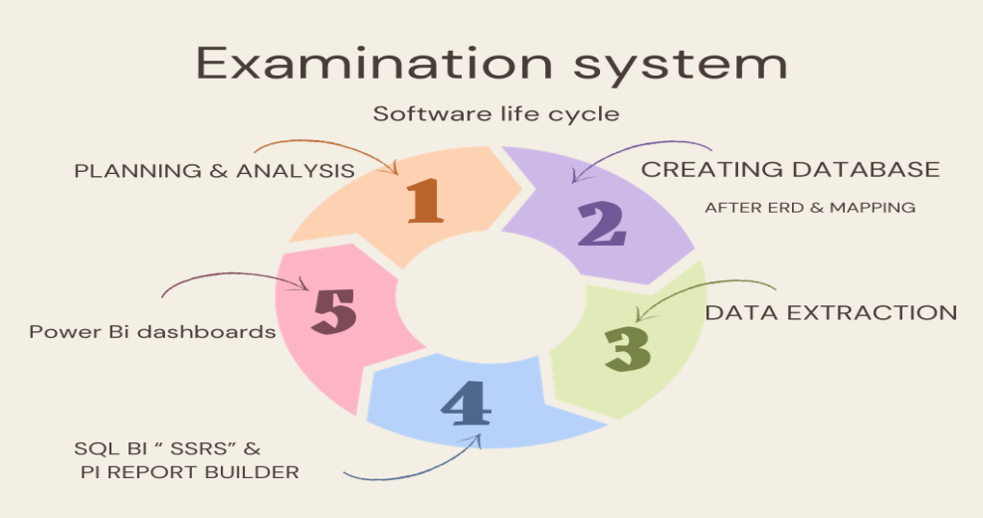

1. **Planning , Analyses and Follow up Using Trello Software:**

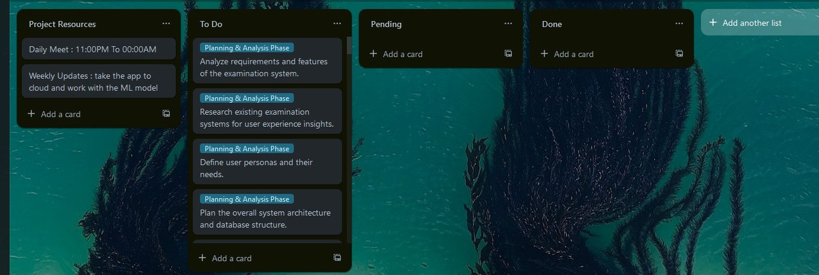

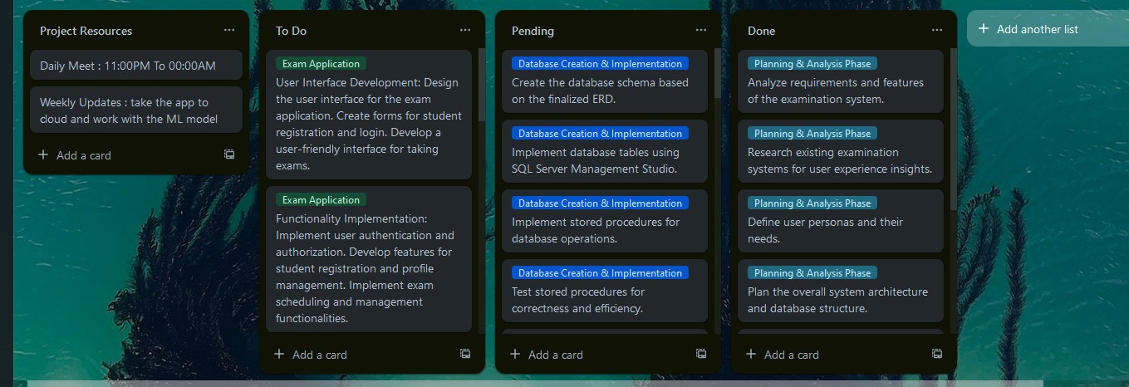

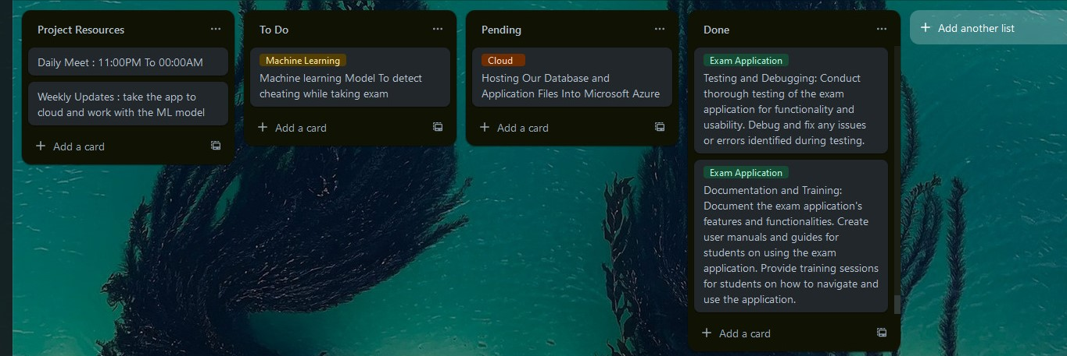

**ERD & Mapping:**   
at this phase we decided our entities and the tables which are :  
{ Student ,Department ,Instructor,Course,Topic,Question,Exam ,Choice ,

Exam_Question ,student course student answer, student exam grade,

Course evaluation,KPI ,Job offer }  
we made the mapping for it after creating it as the below :

ERD:

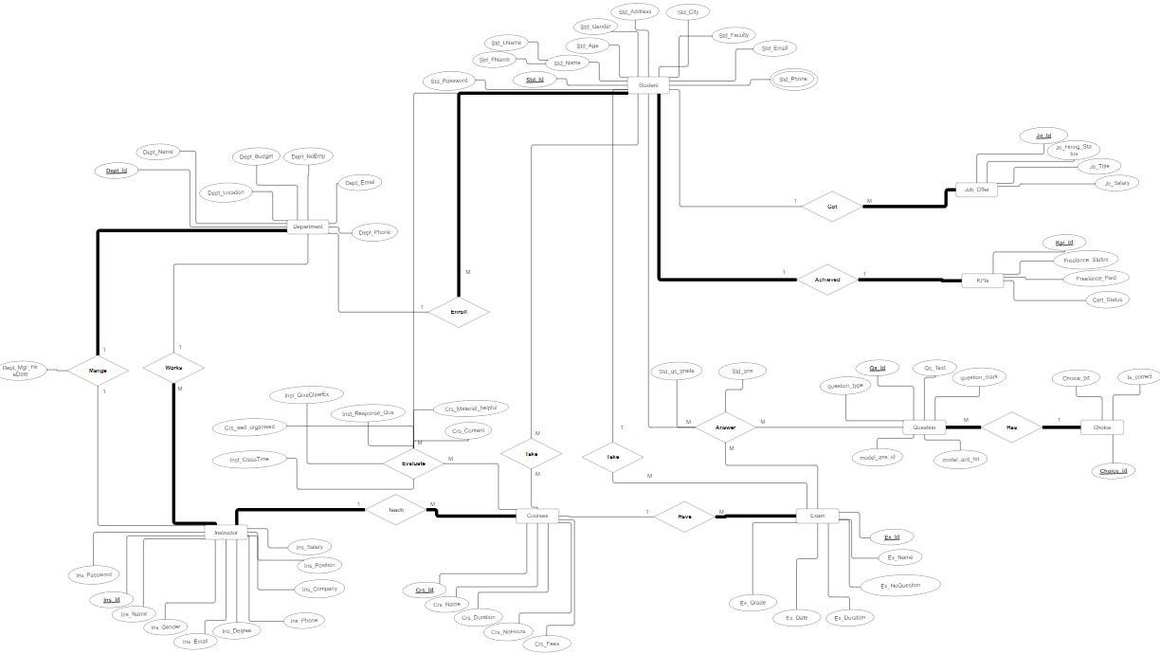

**Mapping:**

**Creating Database & Implementation :**

Creating a database for an examination system typically involves defining tables:  
{Student, Department, Instructor, Course, Question , Exam ,Choice,

Student_Exam_question, Exam_question, STD_Exam_Grade, Std_Phone, Stud_Courcse, Std_Crs_Evaluation, Job _offer }  
Import data directly from Excel files by using the SQL Server Import and Export Wizard.  
**Creation :**  
**1) STUDENT**  
  
**2) DEPARTMENT**

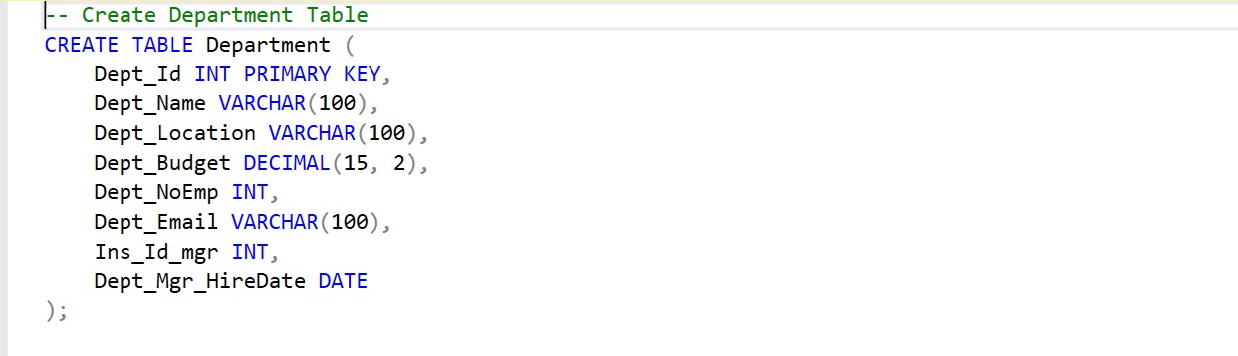

**3) INSTRUCTOR**

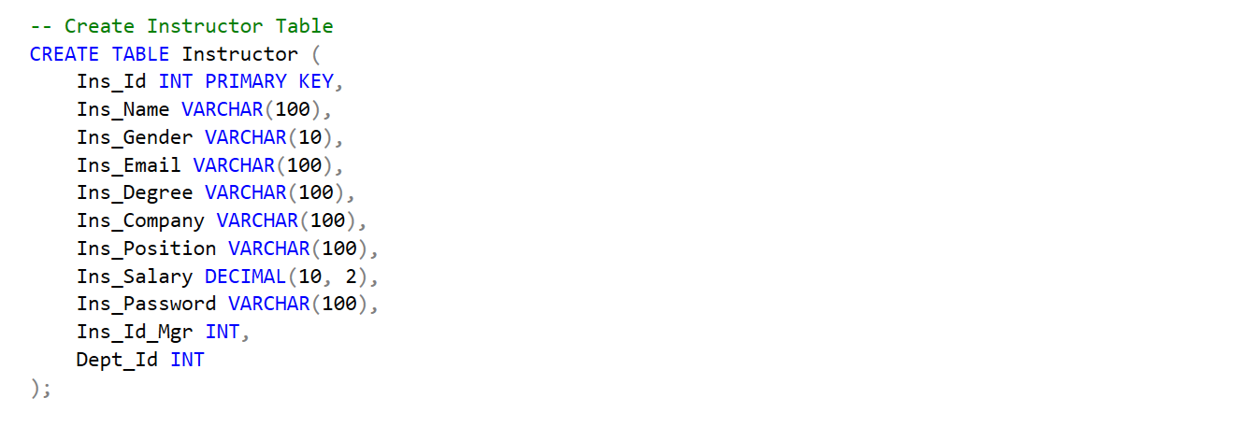

**4) COURSE**

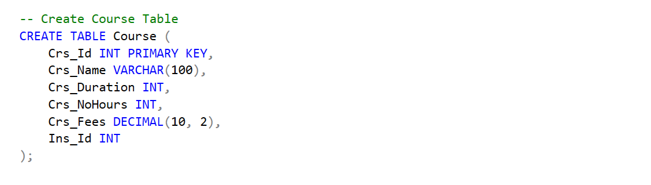

**5) Student Course Evaluation**

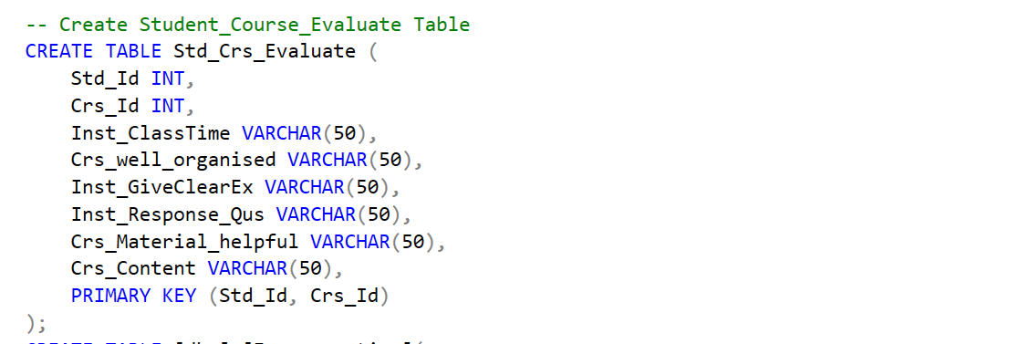

**FOREIGN KEYS:**

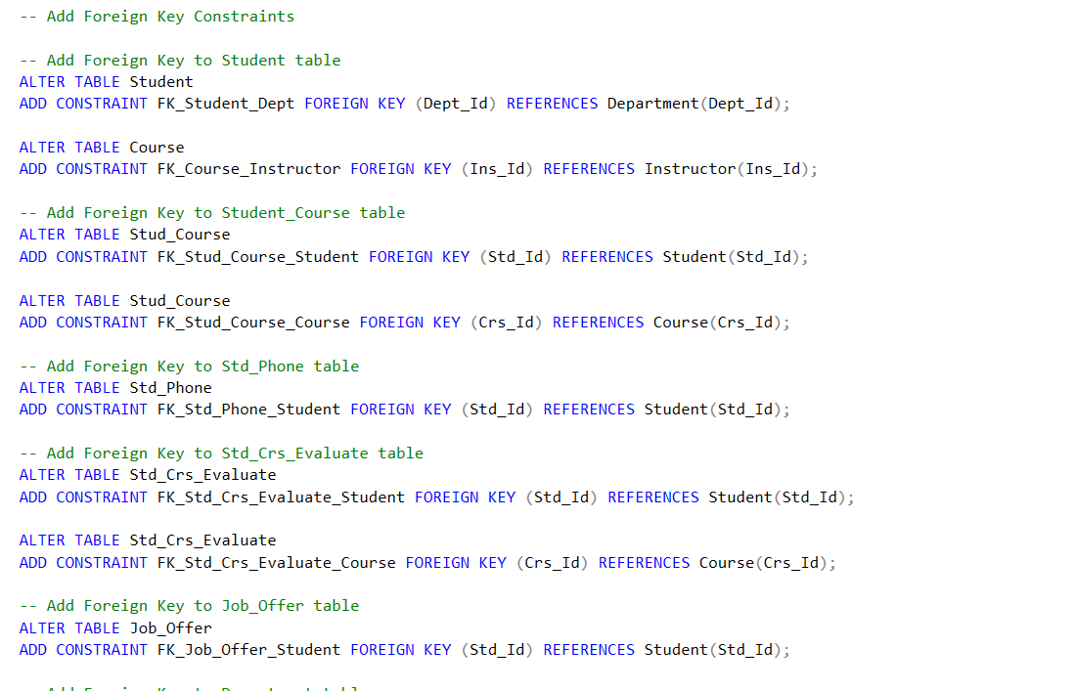

**STORDE PROCEDURE:**

**1) SP FOR SELECT - INSERT :**

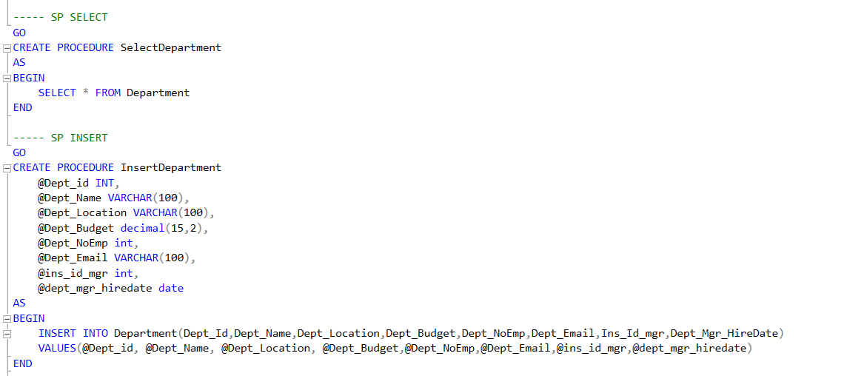

**2) SP FOR DELETE / UPDATE :**

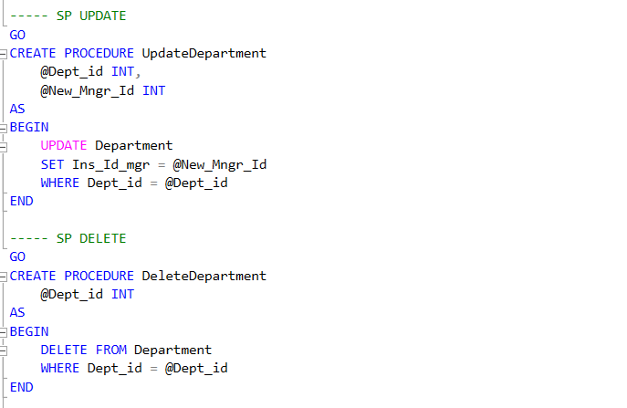

**3) SP_EXAM GENERATION:**

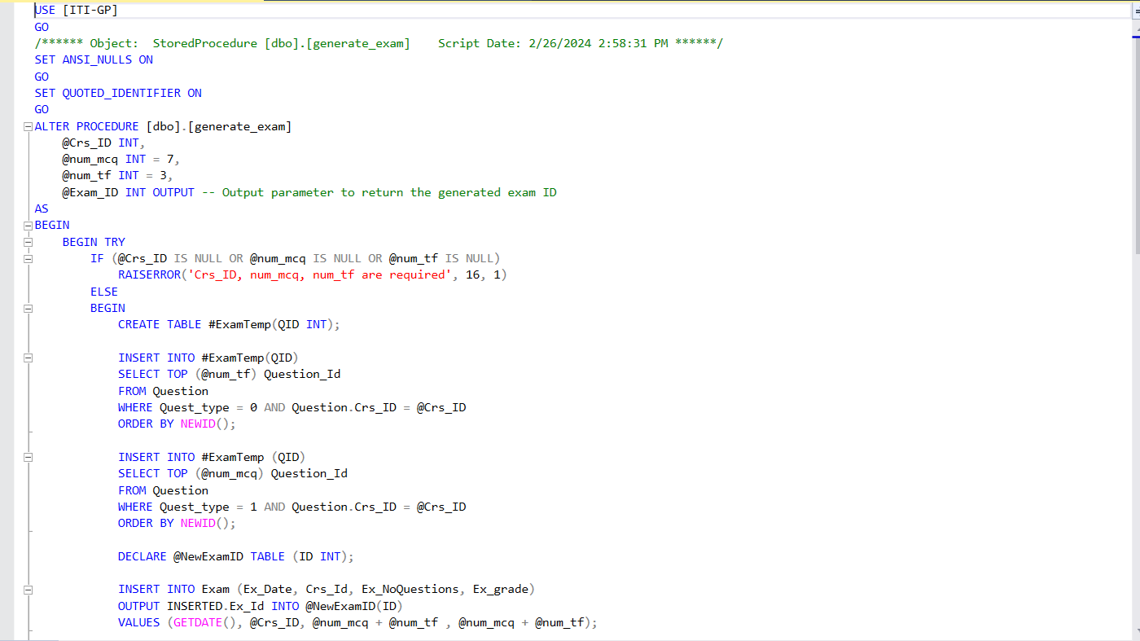

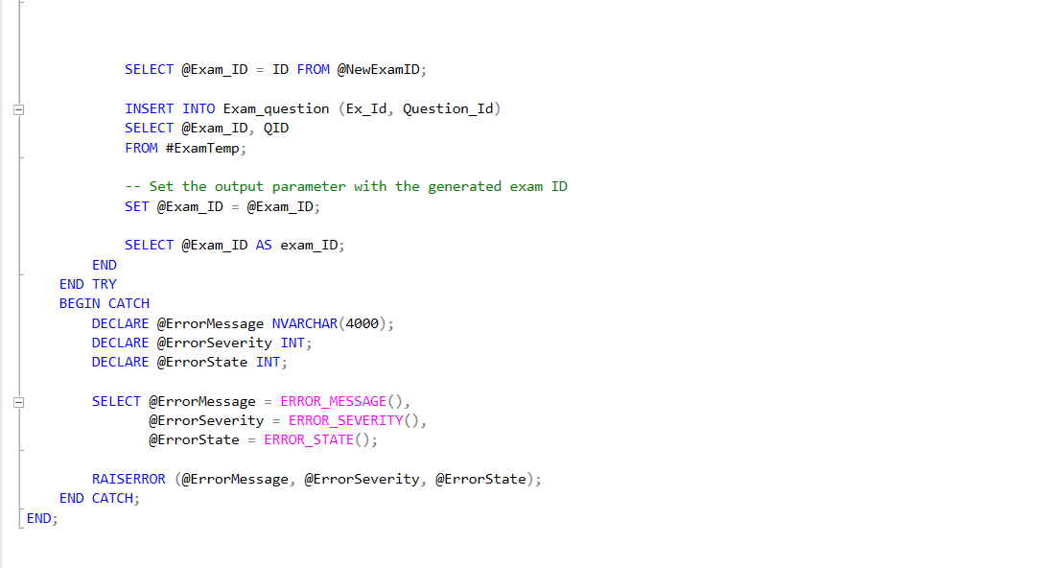

**4) SP_EXAM ANSWER:**

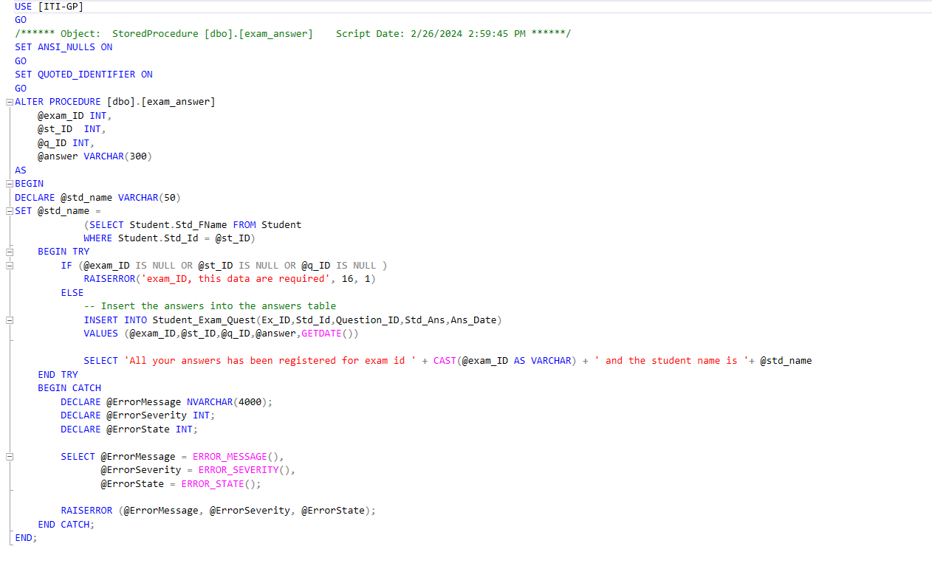

**5) SP_EXAM CORRECTION:**

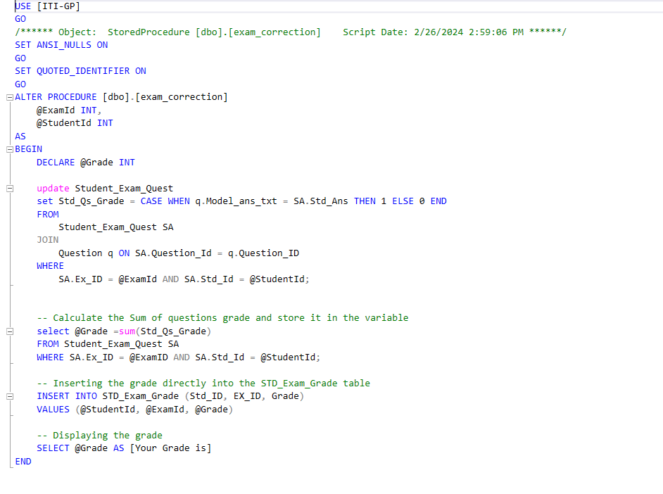

**Generate the Data using RedGate Tool:**

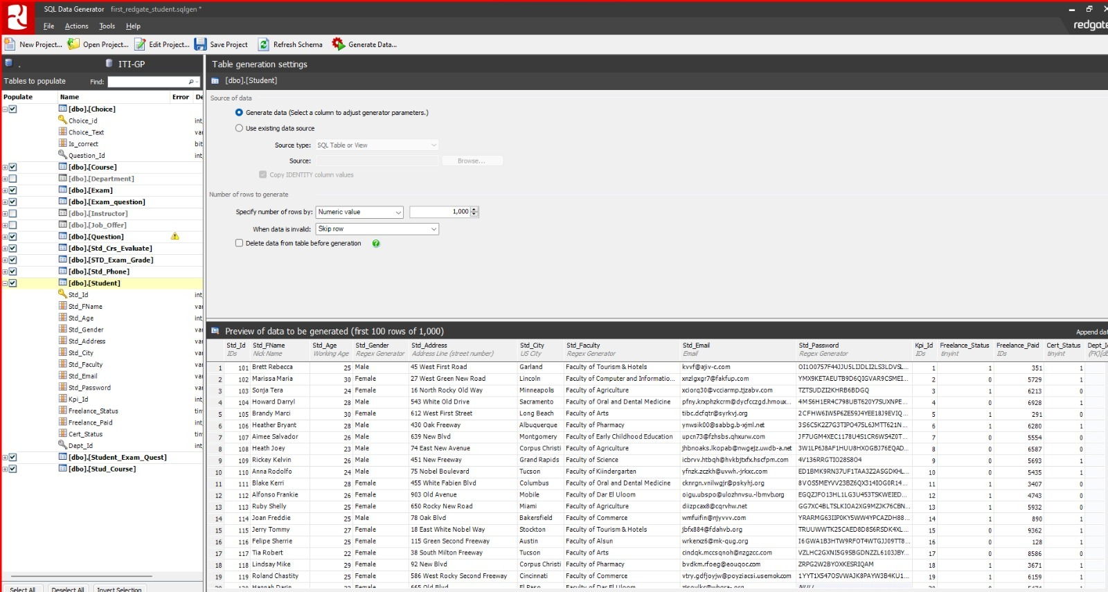

**Data extraction:**   
We have extracted data from a database and used it to create reports in Power BI Desktop, SQL Server Reporting Services, and Power BI Report Builder. The process involved querying the database, saving the data as a CSV file, and then importing it into the reporting tool.

**SSRS:** SQL Serverreport server to present the data from stored procedures to SSRS   
as the upcoming :.

**1) Report** : that returns the students information according to Department NO parameter. 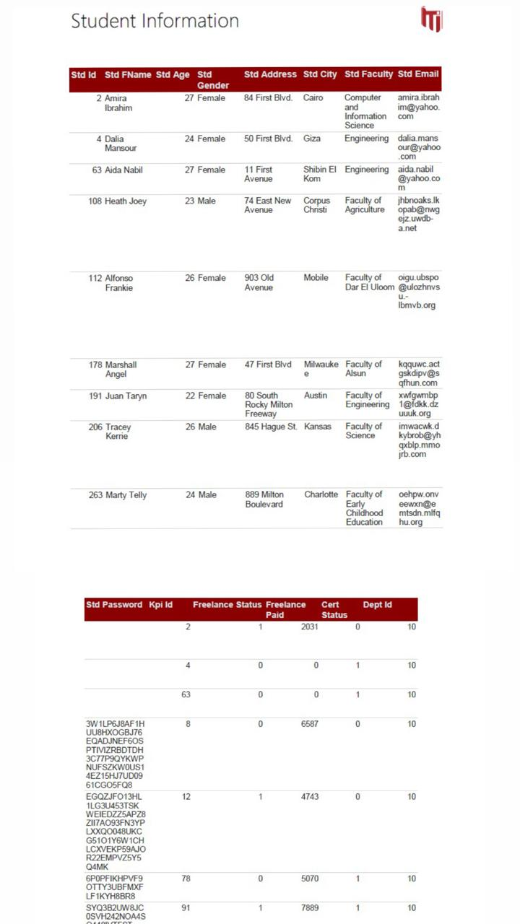

**2) Report** :

that takes the student ID and returns the grades of the student in all courses.

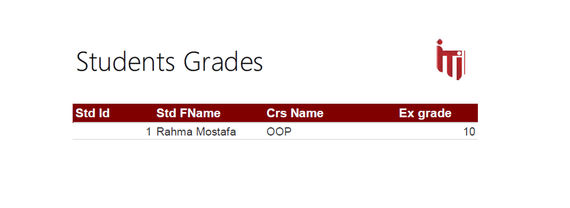

**3) Report :**   
that takes the instructor ID and returns the name of the courses that he teaches and the number of student per course.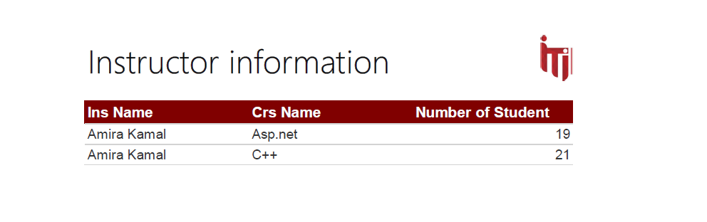

-

**4-Report**:  
that takes exam number and returns the Questions in it and choices   
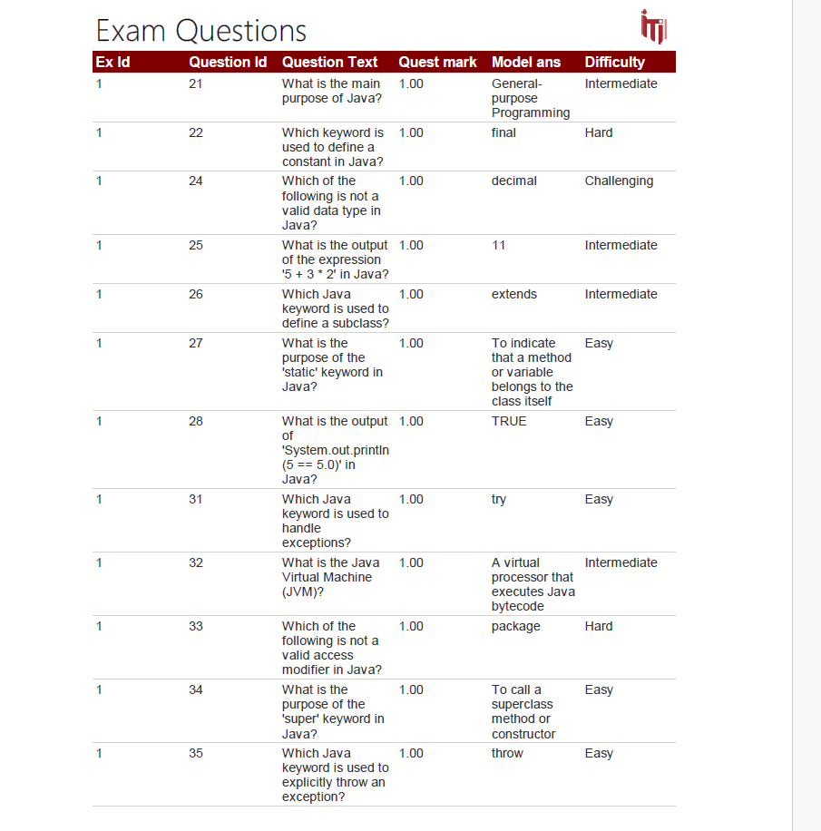

**5-Report**:  
 that takes exam number and the student ID then returns the Questions in this exam with the student answers.

**Power BI Dashboard:**

After the above phases up we came to the time of making the Dashboards that   
supervisor or the manager or any stake holder will use it to analyze the needed data from any table we mentioned in our system to get the important insights that will be so useful in tracking the performance of the system overall.   
we have made 20 dashboards but we will focus now on the main 6 overview in the upcoming screens :

1-**Student overview :**

Here we can see the total number of the students and number due to the gender distribution and the average age , also you can find student by age and student graduation year , and we should mention that we made filter so that you can enter any name for the student and get the needed insight due to the student you wrote his name and there is important navigation buttons in the left side to choose from it thing you need to know from distribution or the KPIs or the job offers or graduated students to get the insights you want

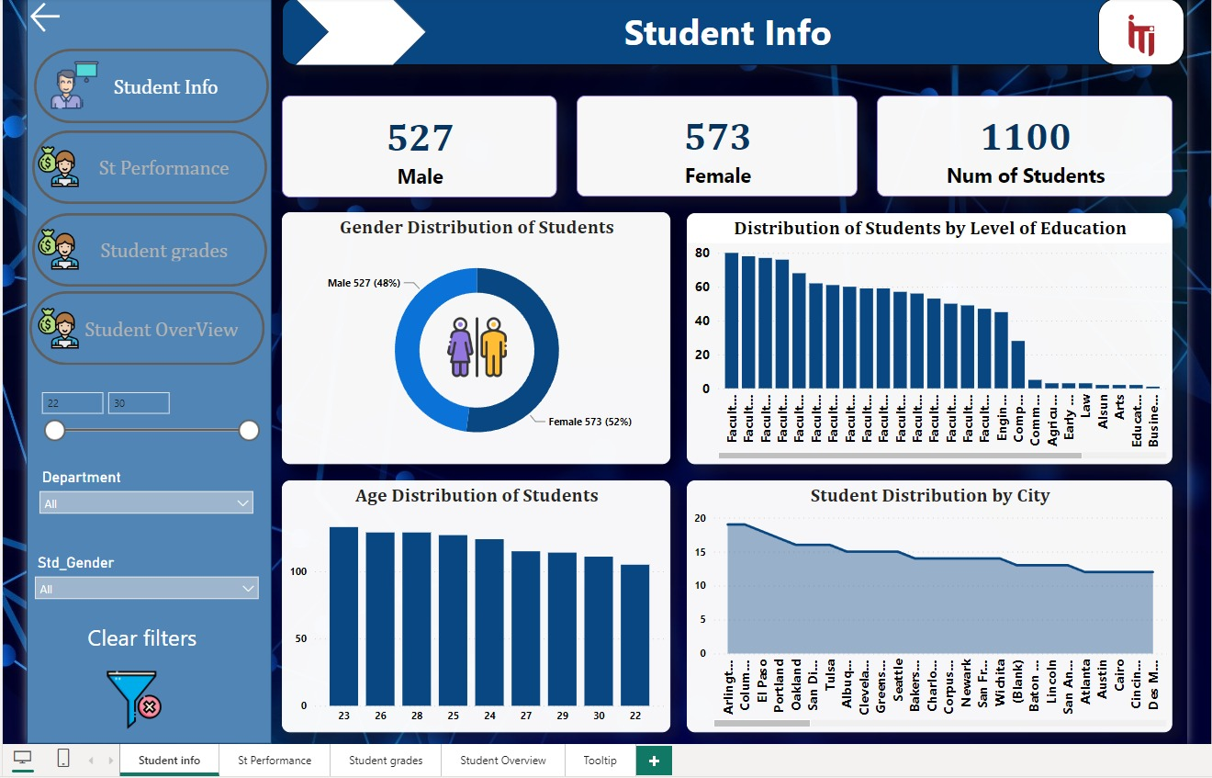

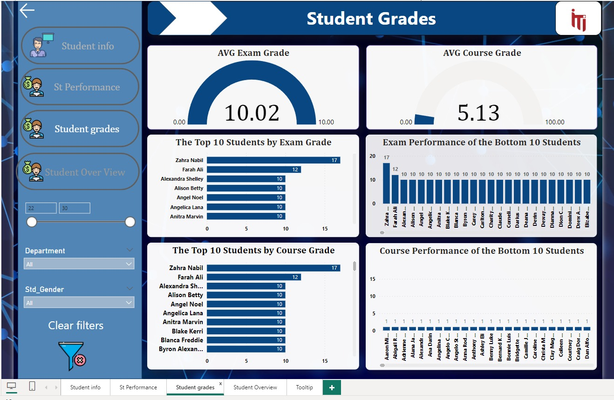  
  
  
  
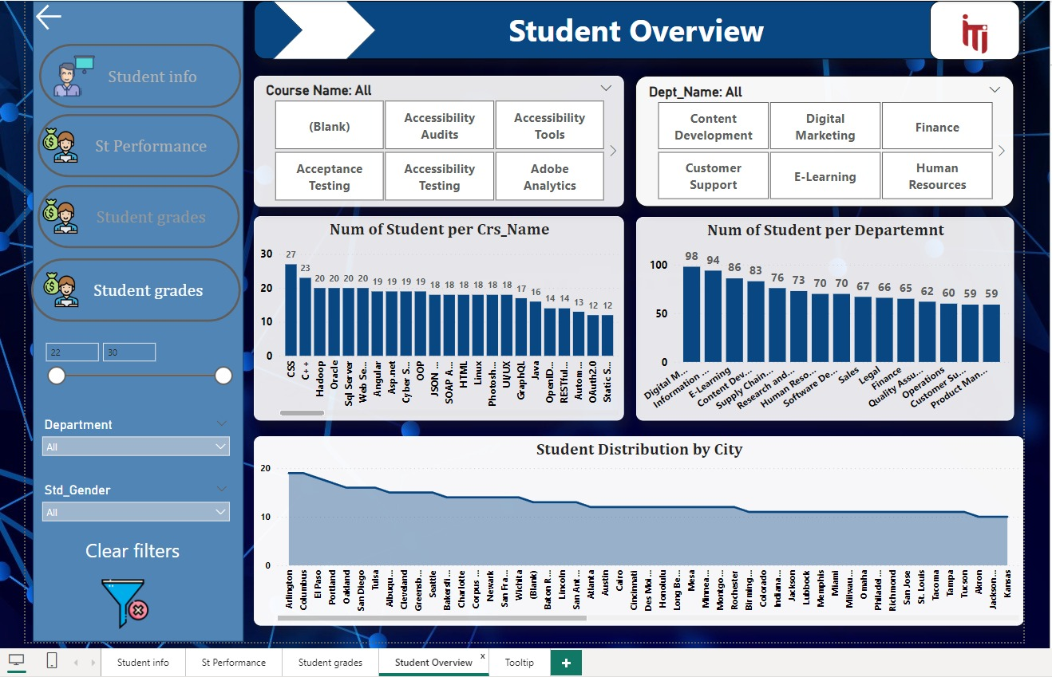

1. **Instructor overview** :

Here we can see there is 2 main filters one by the instructor city and the other by the instructor name to filter the data due this two mentioned then   
when you choose the instructor name you can have its mail , also we made a card to the total number of instructors we have, and number of instructors in each department in the system and also we got map to get the number of the instructor in each city and the distribution of the instructors by its gender  
also you can find in the left related navigation button for the instructors to choose from and they are : feedback or the instructor performance

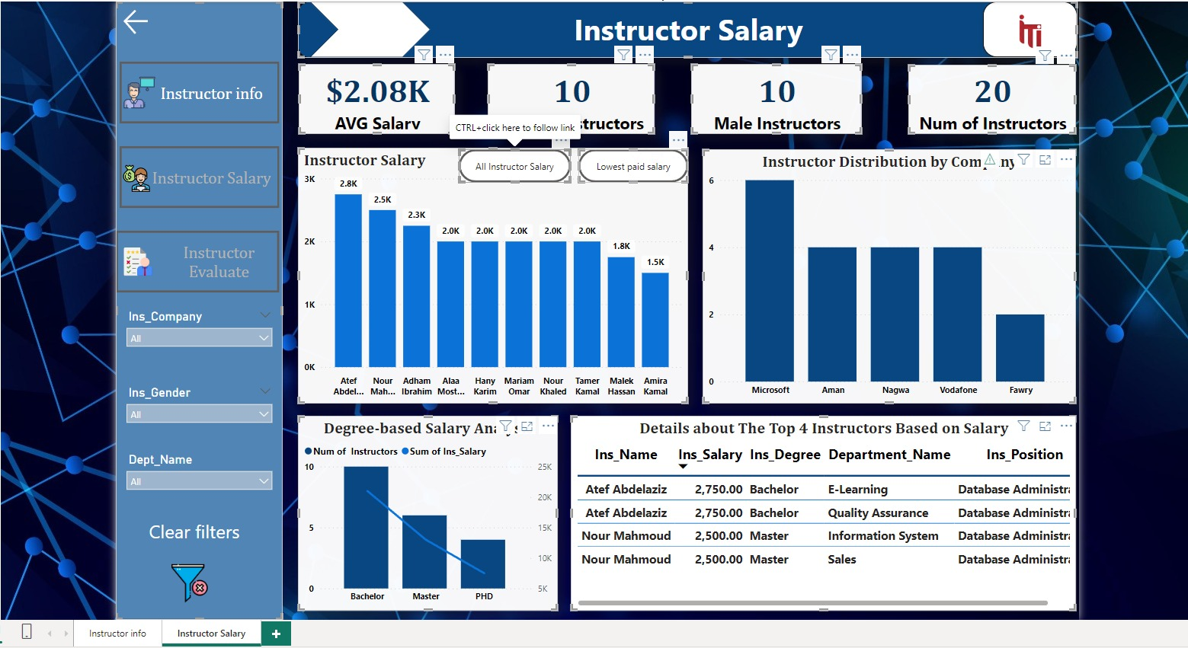

**3-Department overview :**

Here we can see there is main filters on the dashboard here and it is the department name , and when you choose the name the manger of it will show immediately , we made a card to show the total number of the departments we have , and distribution and total number for the instructor in each department and numbers of the departments by its location   
and as usual there in the left you can find 2 navigate buttons to choose from department or department performance

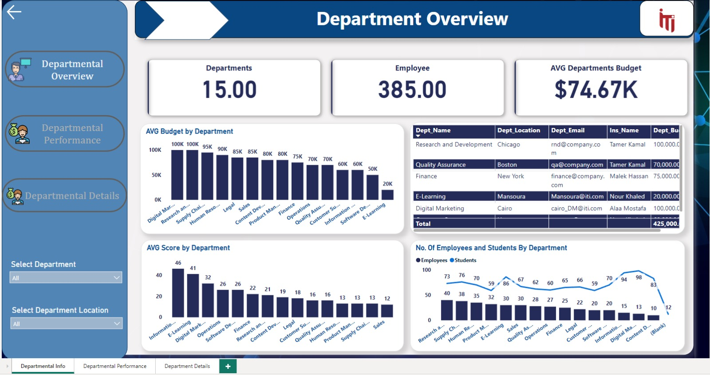

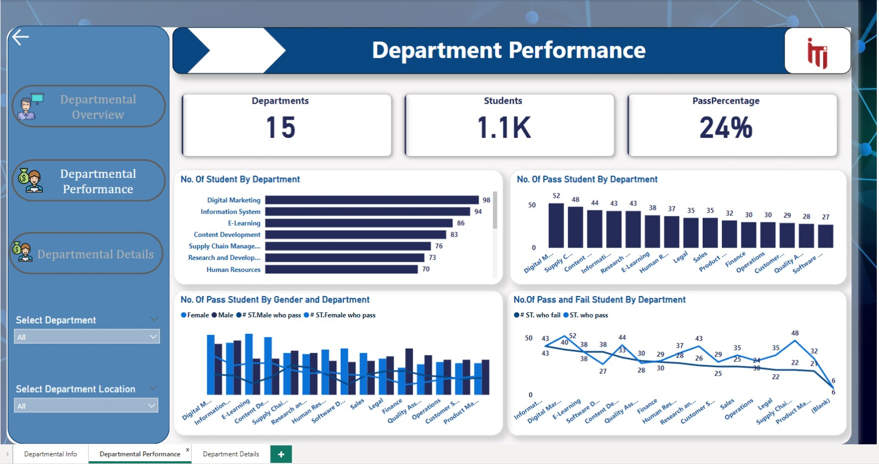

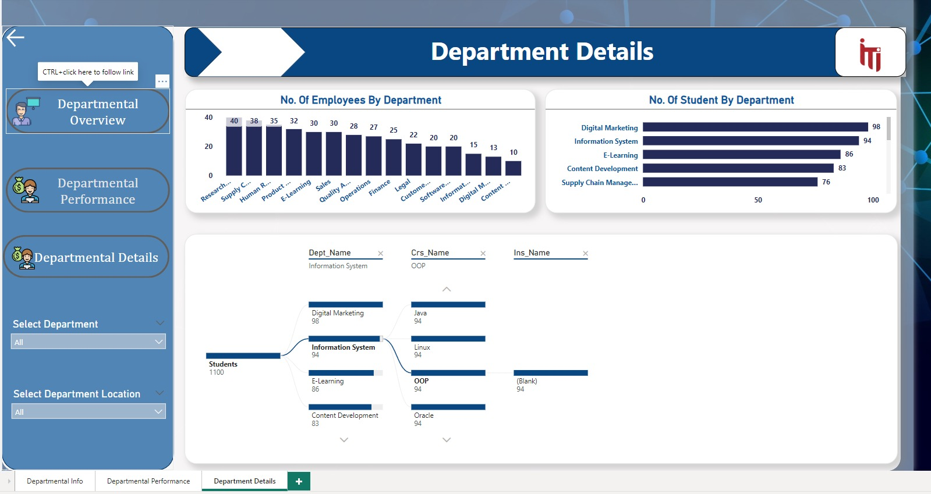

4-Course overview :

Here we can see there is main filters on the dashboard here and it is the course name , and when you choose the name it will show immediately the insights due to it , we made a card to show the total number of the courses and average courses duration , also we have the course duration due to the topic name and the number of courses by department name , also we have table to show information like the course name and its duration and topic name and number of students , and as usual there in the left you can find navigation buttons to choose from course , course grade course feedback and student course

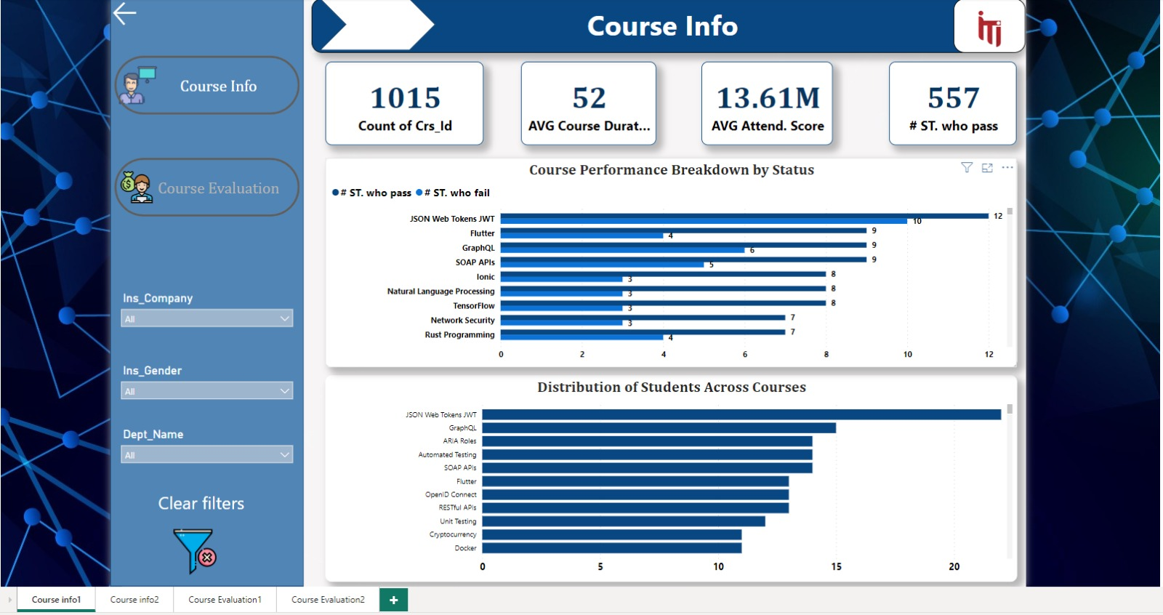

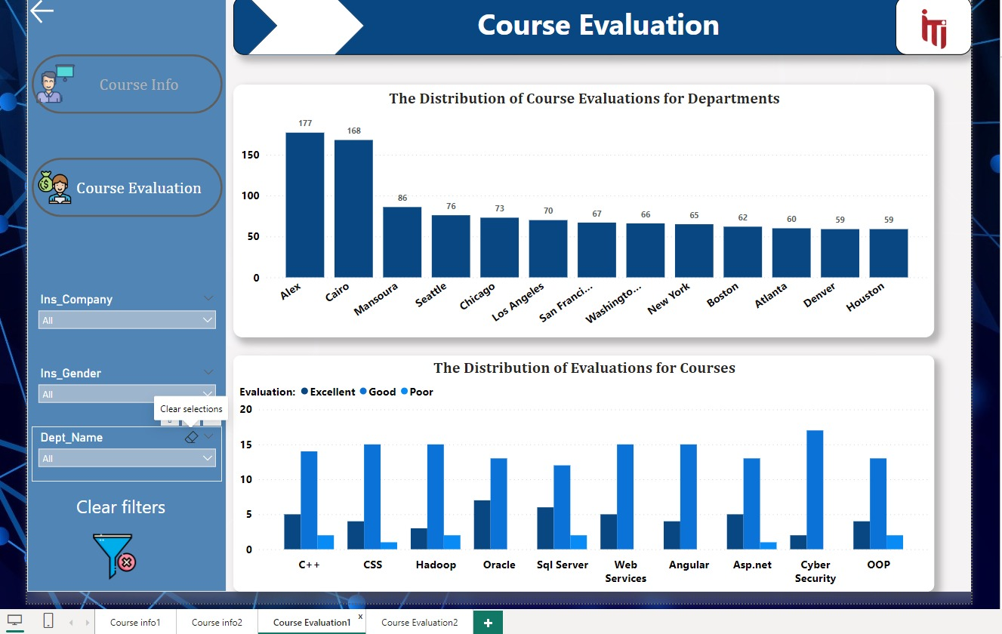

5-Questions overview :

Here we can see there is main filters on the dashboard here and it is the course name , and when you choose the name it will show immediately the insights due to it the total Exams number and number of total questions and exam duration , and also we have the number of exams by the month and number of questions by the question type and a table show information about the exam date and its day and number of exams and its id

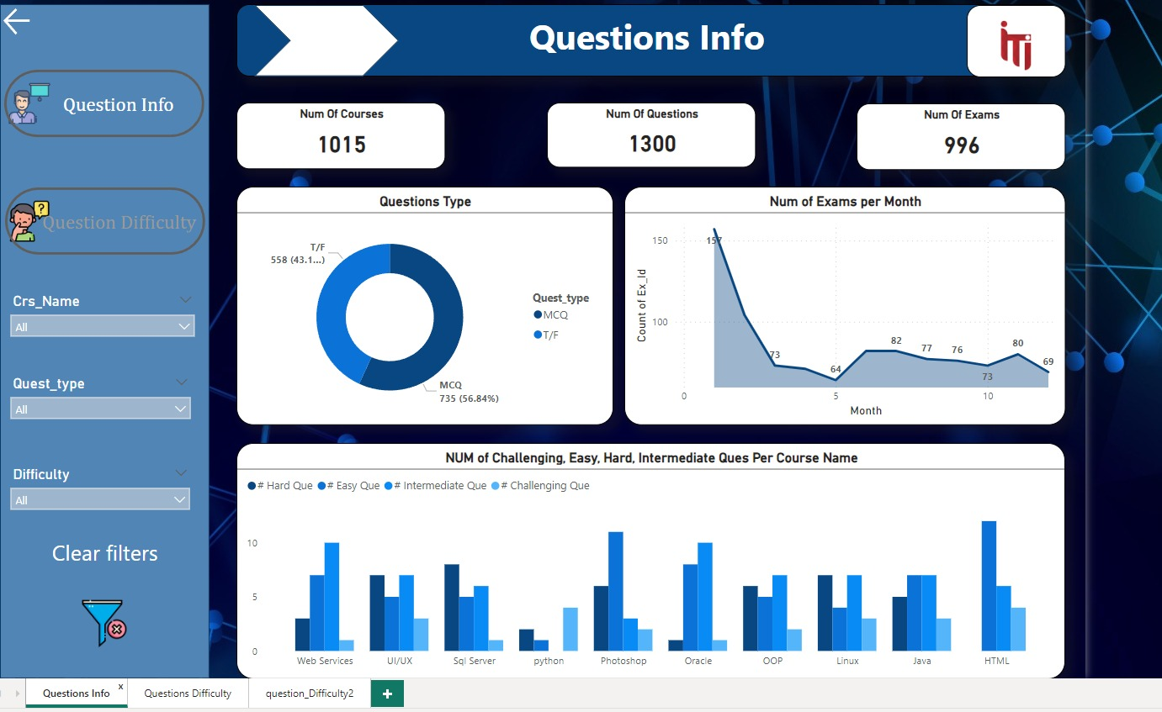

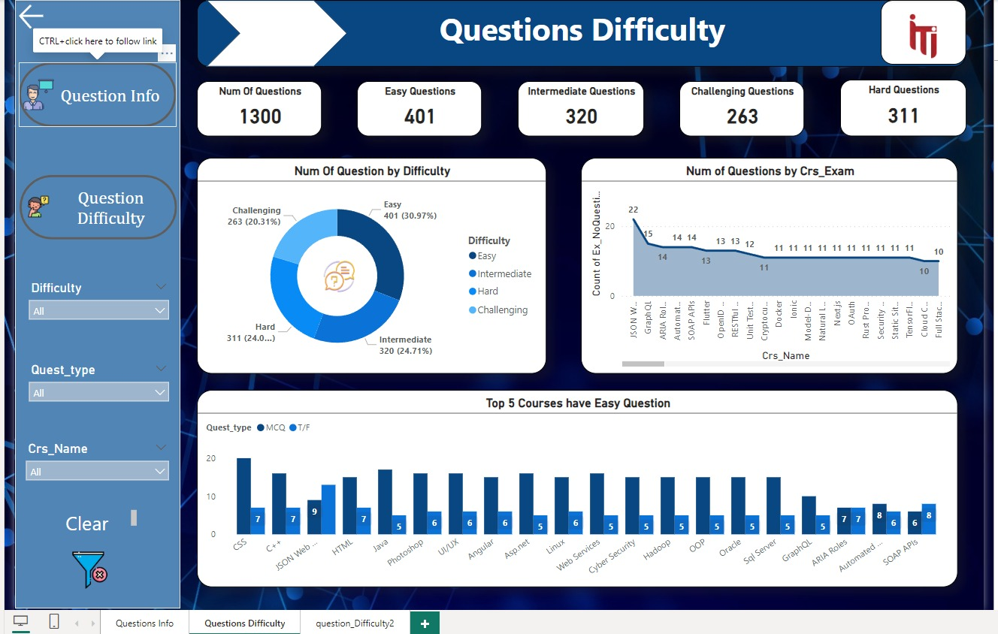

6-KPI & job offer :

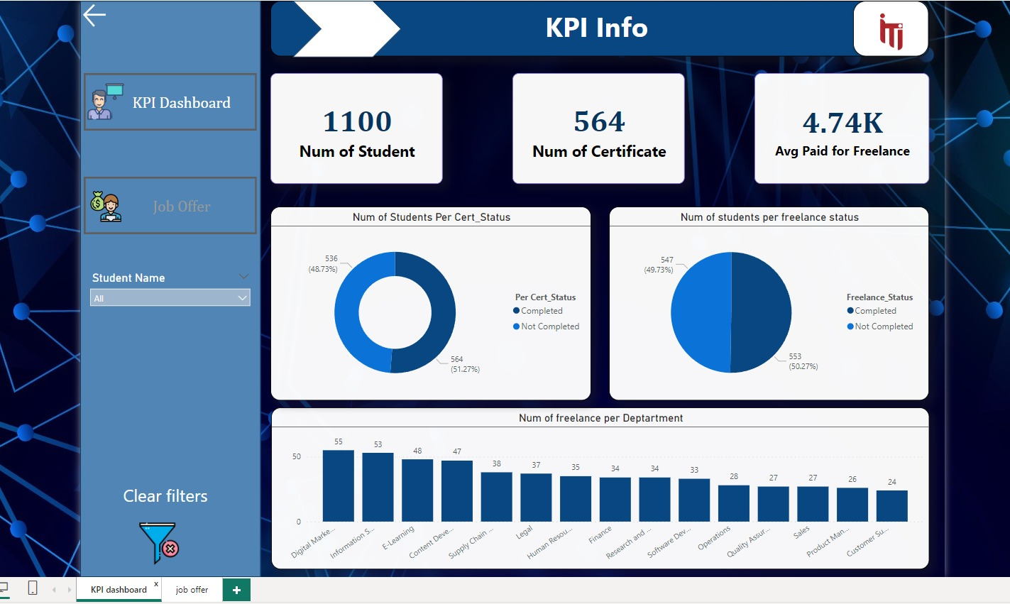

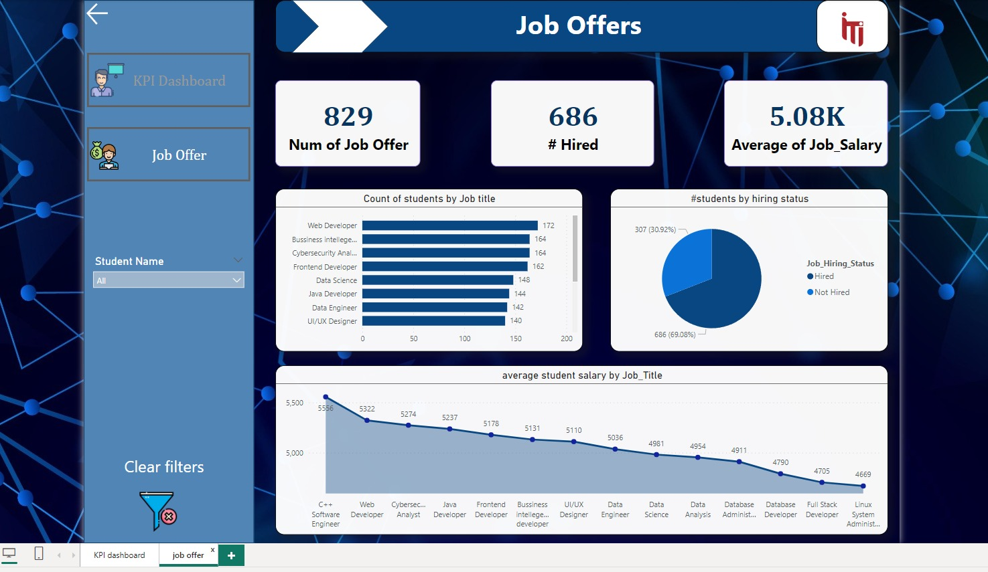

**Examination System Application**

**1. Login Page:**

Purpose:

The login page serves as the entry point for users (students, instructors, and administrators) to access the examination system.

Functionality:

Users input their credentials (username and password) to authenticate themselves.

Upon successful authentication, users are redirected to the course selection page.

Error messages are displayed for invalid credentials or other authentication issues.

Implementation:

Utilizes secure authentication mechanisms to protect user credentials.

Implements input validation to ensure data integrity and security.

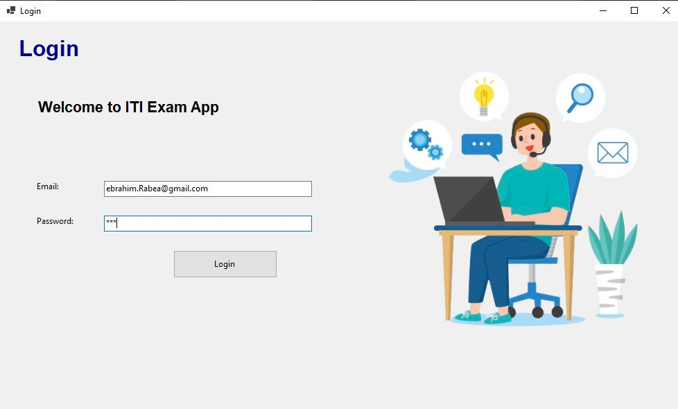

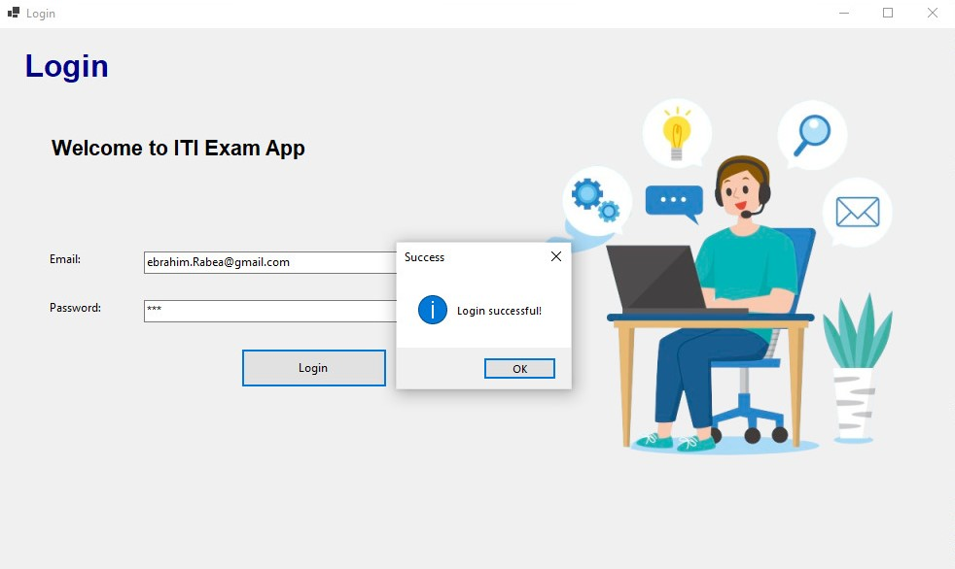

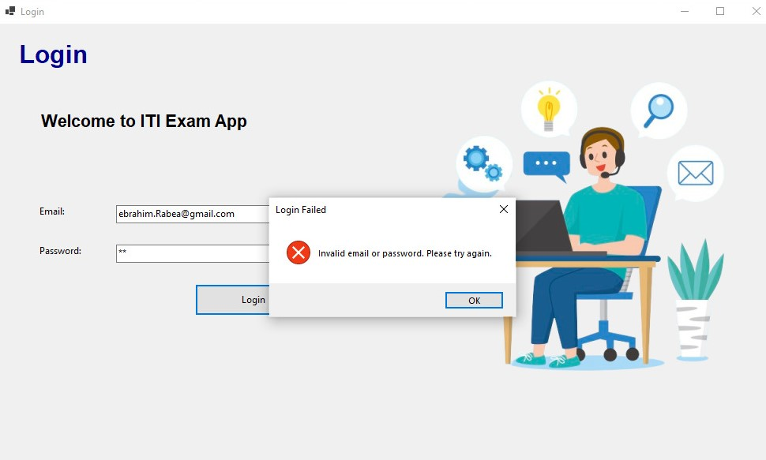

**2. Course Selection Page:**

Purpose:

The course selection page enables users to choose the course for which they want to take the exam.

Functionality:

Presents users with a list of available courses based on their enrollment or access privileges.

Users select a course from the list to proceed to the exam page.

Provides navigation options to return to the login page or log out of the system.

Implementation:

Retrieves course information from the database and displays it dynamically on the page.

Implements secure session management to maintain user context across pages.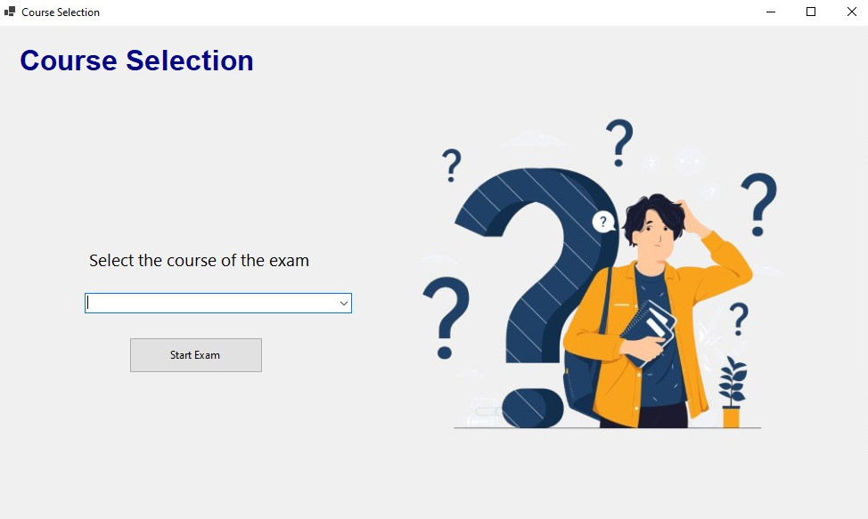

**3. Exam Page:**

Purpose:

The exam page facilitates the administration and completion of exams by students.

Functionality:

Displays exam questions retrieved from the database based on the selected course.

Provides interactive elements such as radio buttons or checkboxes for selecting answers.

Allows users to navigate between questions, review answers, and submit the exam.

Implementation:

Fetches exam questions and choices dynamically from the database.

Validates user responses to ensure data integrity and accuracy.

Implements client-side and server-side logic for exam navigation and submission.

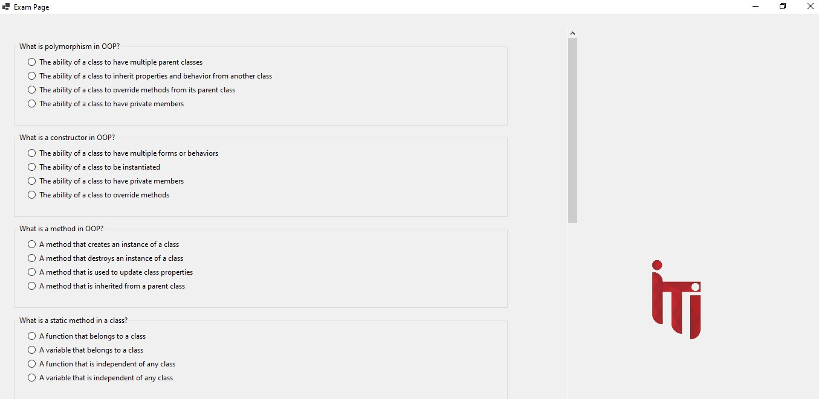

**4. Show Grade Page:**

Purpose:

The show grade page presents users with their exam grades and performance feedback.

Functionality:

Retrieves exam grades and feedback from the database based on the user's exam submissions.

Displays grades for individual exams or aggregated grades for multiple exams.

Provides options for users to view detailed feedback and performance analytics.

Implementation:

Utilizes database queries to retrieve exam grades and feedback securely.

Implements data visualization components to present grades and analytics in a user-friendly format.

